

**UNIFIED MENTOR PRIVATE LIMITED**

**Intern name: Kumari Shruti Jha**

**Role: Data Analyst Intern**

**Internship Id: UMIP8809**

**Date of Submission: 15-07-2024**

**Contact Info: Email:**[**Shrunov17@gmail.com**](mailto:Shrunov17@gmail.com)

**Mobile no.: 8789819002**

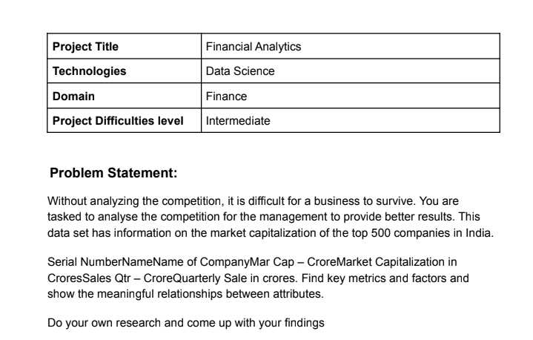

Financial Analytics Project Report:

The approach I have used is to calculate the market capitalization to sales ratio to identify the undervalued and overvalued companies. While the undervalued companies are a potential investment opportunity, the overvalued companies might pose a risk to investment. Finally I have also done some of my own research to identify the correlation between the calculated ratio and the % increase in the closing price of the stock. I have created a dataset of my own. I have explained all of these steps in detail.

1. Visualizing Distributions:

These figures show the distribution of the market cap and quarterly sales.

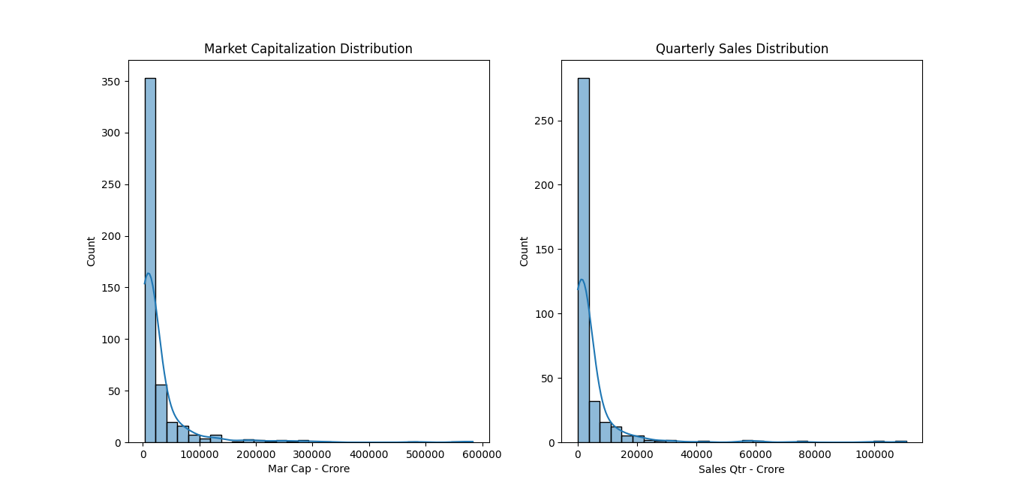

Through this distribution the number of small, medium and large companies on the basis of market capitalization can be found, which in itself can be an indicator whether to invest or not. It also shows the sales value that most of the companies have.

1. Outliers in Market Capitalization and quarterly sales:

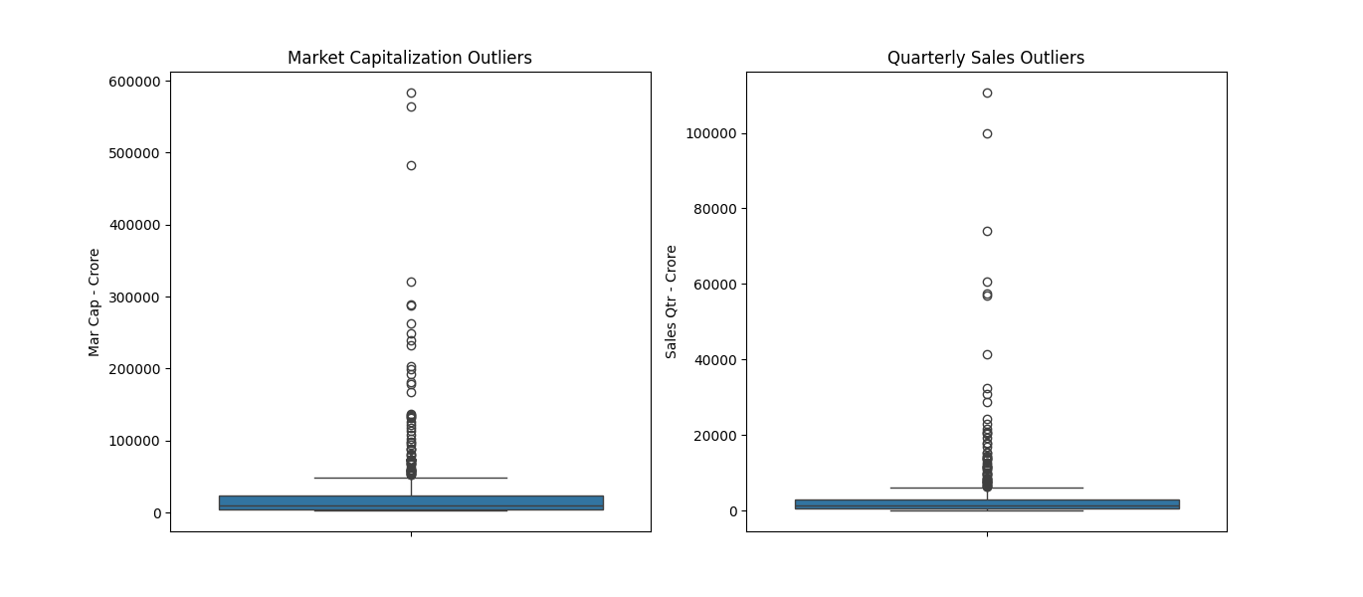

This boxplot correctly shows the range in which the market capitalization and quarterly sales values fall in. The values which lie outside this range are the abnormally high values, which again signify something which does not fit the normal distribution. There might be risk associated with investment in these particular companies.

1. Market capitalization versus quarterly sales:

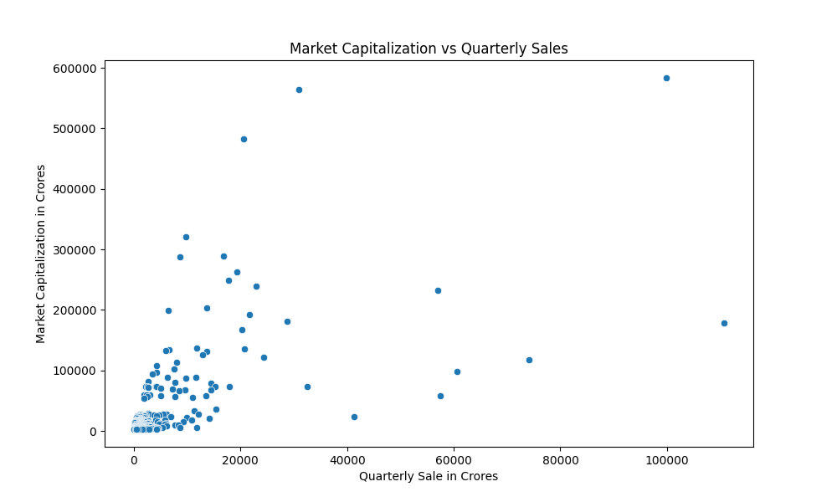

* + The versus plot shows some significant points:
  + The points lying closely scattered at the origin of the graph are the ones which will have medium ratios of both quantities, which means that the valuation of these companies is somewhat right. These companies would be a perfect fit for investment with minimum risk.
  + The points lying above the close cluster are the ones which are overly valued and have potential risk of investment.
  + The points lying below show potential opportunity, but again investment cannot be based on only one fundamental factor, therefore these companies will have high risk as well as high returns.

1. Ratio Calculation:

The logic behind this ratio is that it will indicate whether the valuation of that company is correct or not. The overvalued companies will have risk of investment as their stock price may fall, while the undervalued companies might give better returns. The following bar graph illustrates the top 10 companies with highest and lowest ratios.

The figure illustrates the companies with the lowest ratios and highest opportunities.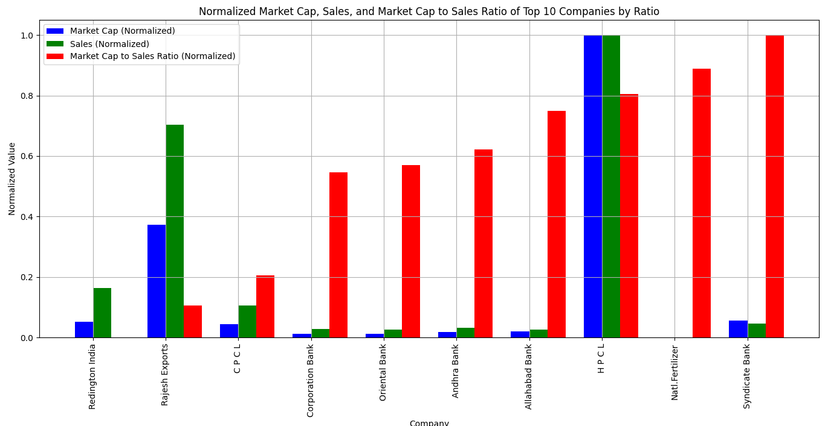

The figure illustrates the companies with the highest ratios and highest risk.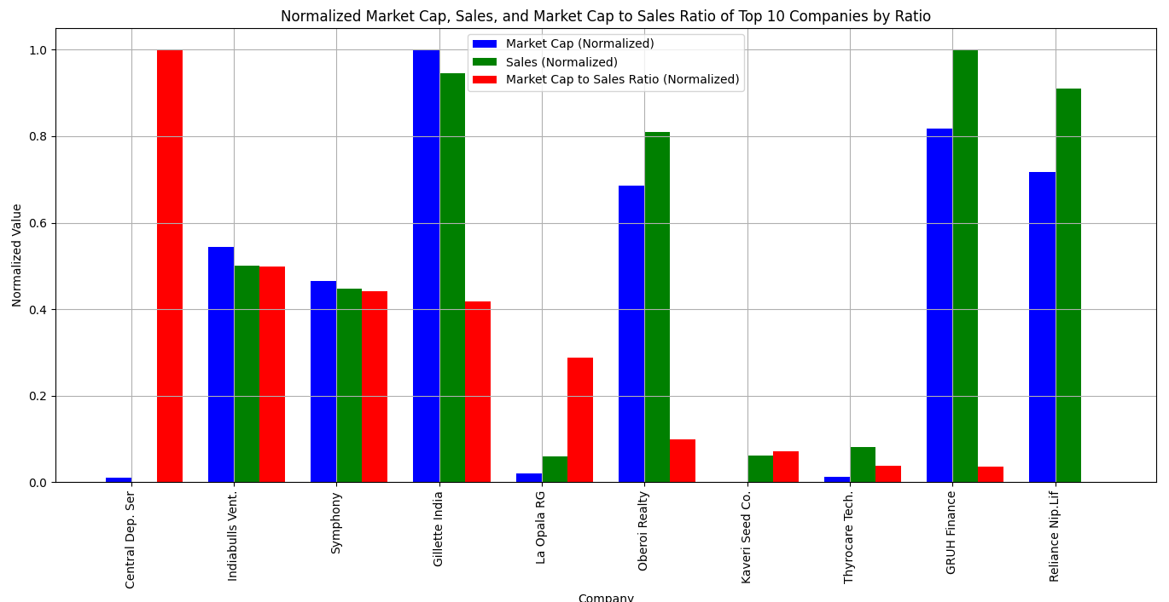

1. Self defined approach for better analysis:

To understand the data better, I have created a dictionary of some stock names alongwith their ticker symbols. I am using yfinance to fetch their fundamental data and then calculate the same ratios defined above, finally I am also fetching the close price data and calculating the %change during the same date in which the fundamental data has been fetched. Then a correlation has been performed to understand whether it is actually related with the parameters.

1. Dataset creation:

The dictionary was created manually and then yfinance was invoked to fetch the data. A glimpse of the data:

Self dataset which was created for analysis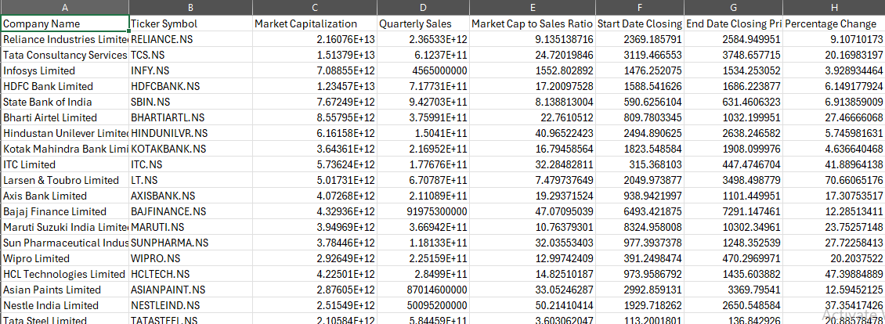

1. Correlation analysis:

The percentage change was correlated with the three parameters to identify if indeed there is some relation.



The correlation of the percentage change and the other three parameters is significant. It just shows that the lesser the ratio, the more percentage change has been observed. With growing sales, the percentage change has also grown and with more market cap there is a negative correlation, which means that % change is less for huge market cap companies. Therefore these findings indicate that indeed the market cap to sales ratios can be use for analysis. It can be better understood using these figures:

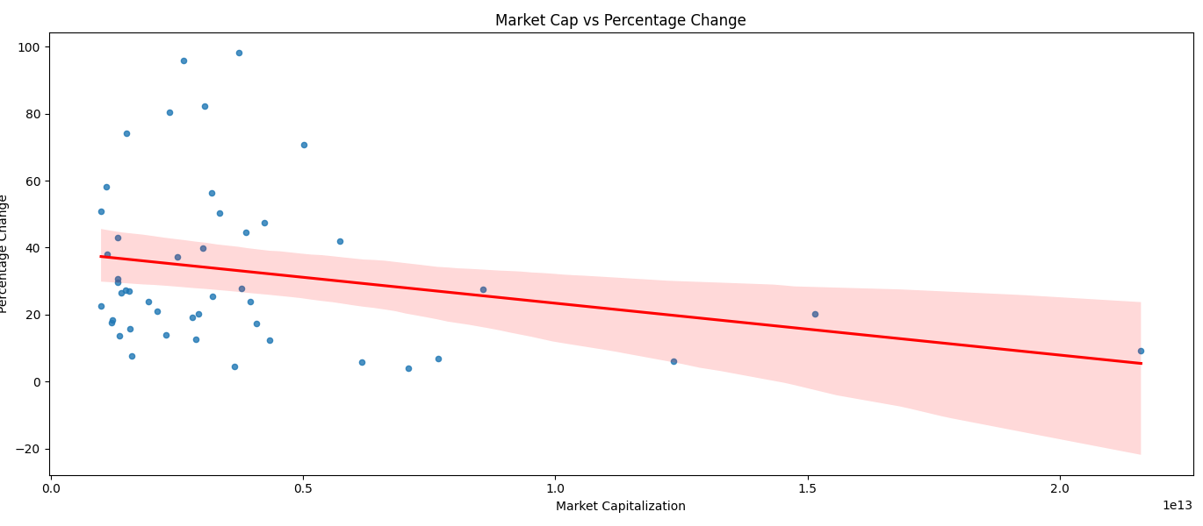

With less market cap the %change observed is significant, while with high market cap the %change is negative.

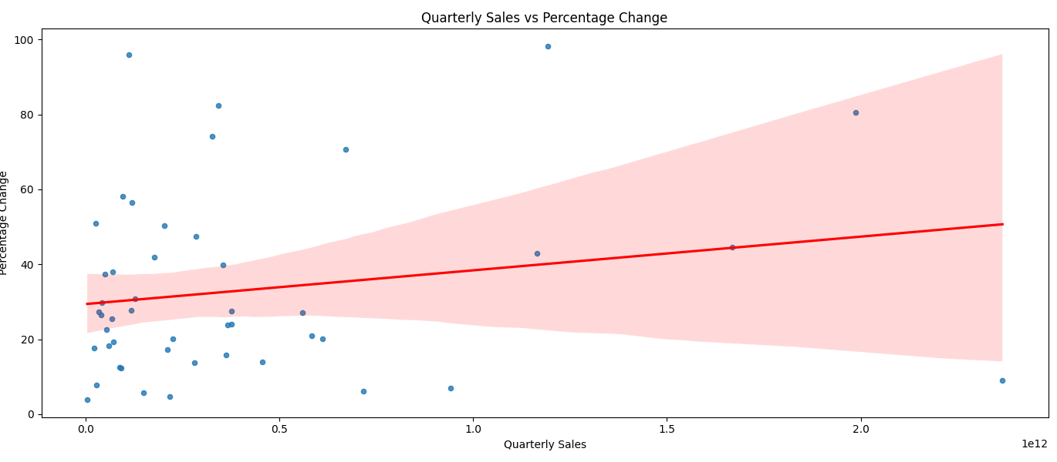

It can be seen that the overall relation is positive with the sales value for %change, as sales increases the %change also increases. It is best for intermediary values.

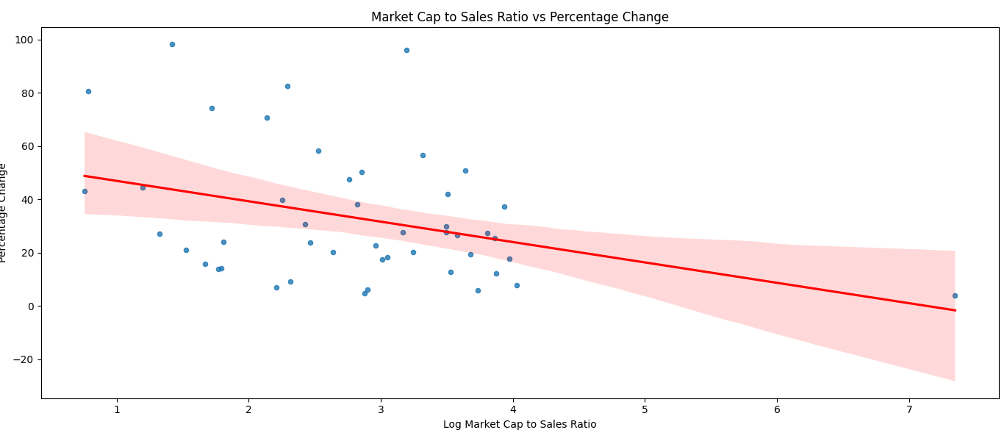

Due to positive correlation of sales and negative correlation of market cap, the overall correlation is negative for the ratio. It can be observed that as the ratio increases the %change progresses to negativity. All of these findings justify the hypothesis made at the starting of the project.